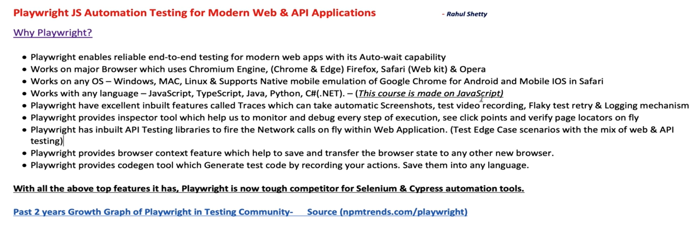

Web ApI testing

We used browser to create new context, in API we use request to create context